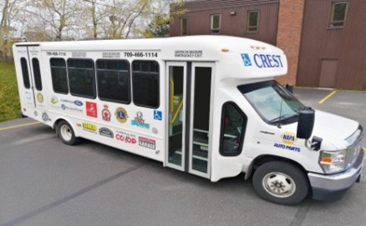 CREST 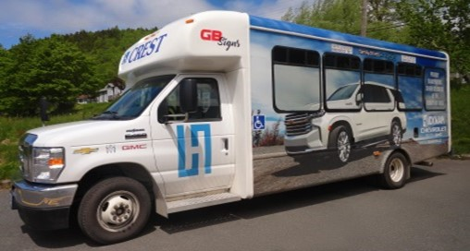
Clarenville Region Extended Seniors’ Transportation

BUS SCHEDULE

- The bus operates in 12 communities—Clarenville, Milton, George’s Brook, Harcourt, Random Heights, Elliott’s Cove, Snook’s Harbour, Deep Bight, Adeytown, Hillview, North West Brook, and Queen’s Cove.

- The service operates in all communities everyday--Monday to Friday from 8 a.m. to 4 p.m., excluding statutory holidays

- There is a $2 cash fare per person each way. Please use correct change.

- Save with a bus pass--11 rides for $20.

Call 709-466-1114 to book your ride!

If you do not live in one of the listed communities and would like to use the service, you can arrange to be picked up and dropped off at a location in one of the communities
that are listed.

