CREST

CLARENVILLE REGION
EXTENDED SENIORS’
TRANSPORTATION

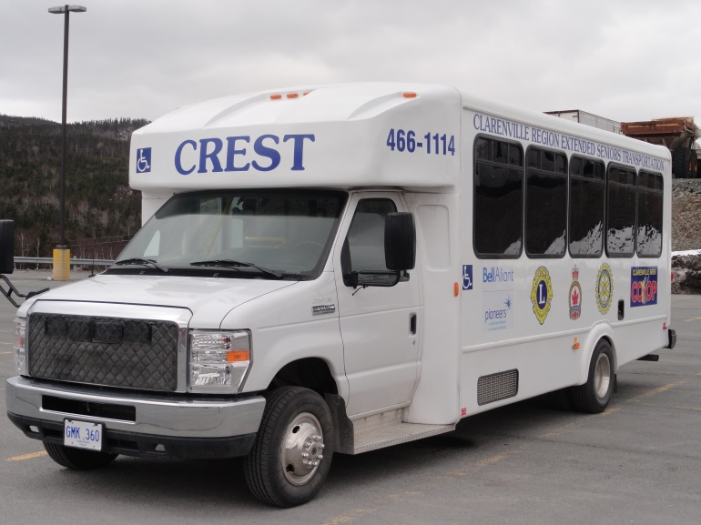

CUSTOMER INFORMATION HANDBOOK

709-466-1114

2nd Edition, October 2016
WELCOME TO Clarenville Region Extended Seniors’ Transportation (CREST)--a pilot project under the Age-Friendly Newfoundland and Labrador Transportation Project

CREST is a Clarenville and area service for people:
- over the age of 60
- over age 25 and confined to a wheelchair
- who live within 20 km radius of town of Clarenville

CREST is a shared-ride public transportation service that operates a sixteen-passenger/8-wheelchair bus, Monday - Friday, providing there are confirmed reservations and resources are available to operate the bus.

Office hours for booking rides on CREST are 10:30 am to 2:30 pm.

Booking and scheduling decisions are made to allow as many riders as possible to use the system while staying within our budgetary guidelines.

The cost of operating CREST is covered by a start-up grant from the government of Newfoundland and Labrador, donations from service organizations and businesses as well as fares collected from users.

CREST provides service within Clarenville and as far as Queen’s Cove, Harcourt and Snook’s Harbour on a shared-ride “accessible door to accessible door” basis, providing a safe and secure trip from origin to destination.

At no time will drivers/assistants enter a customer’s home. If customers require help to enable them to be ready to go when CREST arrives, it is the responsibility of the family or caregivers to make sure they have the assistance needed.

Any person who fights, swears, uses insulting or obscene language, smokes, spits or engages in unseemly or disorderly conduct may be temporarily or permanently suspended from using the CREST service.

BOOKING, CUSTOMER CARE, & GENERAL INQUIRIES:

Bookings must be made by noon of the day before you wish to travel on CREST. Customers are booked on a first-come, first-served basis.

CREST is not intended to provide an emergency medical service. If you are experiencing an emergency, call the ambulance for your local area.

CREST does not operate on statutory holidays.

The governing committee will consider requests for special events or group bookings on days when there is no regular CREST schedule. Approval will depend on resources and budget restrictions.

Step 1: To book, call (709) 466-1114
Monday - Friday, 10:30 am - 2:30 pm

All phone messages are checked and followed up during office hours.

Step 2: Provide the following information:

- Name of customer(s) and number of attendants
- Telephone number (home & cell if available)
- Street address & house number
- House identification if house has no number
- If more than one door to house/building, location of door for pick-up
- Time pick-up requested
- Mobility aids used (cane, wheelchair, walker)
- Health concerns (e.g. poor sight, speech problem, communication concern)
- Seat belt exemption (if applicable)
- Destination
- Address and exact time and details of pick-up for return trip, if booking a return trip.

Step 3: Review and confirm booking details before ending the call.

Step 4: Be ready for pick-up.

On-time service and customer-ride time is greatly affected by CREST having to wait for customers to be ready. Your cooperation by being ready at the start of your pick-up window will improve your own service quality as well as the service quality for your fellow travelers.

CREST has a service standard of a 15-minute early/late window, which means your bus could arrive to pick you up as much as 15 minutes prior to or 15 minutes after your scheduled time. If no activity is seen within 5 minutes of arrival or contact, driver must continue on route to maintain service for other customers.

Drivers/Assistants will not search buildings or other areas for passengers not visible at the outside door during the scheduled pick-up window. Please ensure the building is open or, if you have someone meeting you, make sure that person is available at the earliest drop-off time. You need to be at the exterior set of accessible doors at the beginning of your pick-up window (i.e. the door closest to the street).

Cancellations: Customers should call the Booking number (466-1114) as soon as they realize they will not need to use the CREST transportation service.

Ride cancellations should be made by noon the day before you were booked to use CREST transport service.

Unexpected occurrences such as illness, family emergencies, etc., can happen to anyone occasionally and disrupt our daily routine. We understand that these circumstances arise. However, cancelling your trip in a timely manner helps ensure that your seat is available for someone else to use!

If you repeatedly book and fail to cancel, your right to use the CREST service could be cancelled.

All cancellations and other trip changes such as pick-up time and destination are to be made through the CREST office and not the drivers.

Please remember that the driver can only wait five (5) minutes upon arrival within your scheduled pick-up timeframe because of other customer commitments.

FARES

(Subject to Change)

$2.00 cash fare per person. Attendants/caregivers must also pay the $2 fare. Exact change is required.
Bus passes can be purchased--$20 for 11 bus rides.

PRIVACY

Personal Information provided for booking with CREST is kept confidential and is only shared with volunteers who need this information to provide you with the transportation service provided by CREST.

CREST DRIVER/ASSISTANT DUTIES

CREST Drivers/Assistants are permitted to:

- Operate power lifts and ramps on the vehicle.
- Secure wheelchairs and scooters to the floor of the vehicle using the vehicle restraint system. Assist customers with lap/shoulder straps and belts.
- Assist customers on and off the vehicle.
- Assist customers between the vehicle and the inside of the first exterior set of accessible doors at the place of origin and/or destination. An accessible door is an outside door with no more than one step.

CREST Drivers/Assistants are not permitted to:

- Assist customers in climbing more than one step.
- Make any repairs or adjustments to your equipment.
- Transfer customers from a wheelchair or mobility device to any kind of lift or mobility device.
Customers who need assistance with mobility must have an attendant or caregiver who will provide required assistance.
- Help with parcels or baggage. Limit your possessions to those that you or your assistant/caregiver can carry.
- Store packages/parcels. There is no storage space on the CREST bus. Packages/parcels must be carried on your lap. Bags cannot be stored in the aisle of the bus.
- Take your equipment down the steps and then go back for you. All equipment must be at ground level when the driver arrives.
- Enter your premises under any circumstances – including garages.
- Lock any doors to your premises on your behalf.

PASSENGER SAFETY

Seat Belts and Securement

CREST is dedicated to the safety of every passenger on every trip. To ensure the safety of both passengers and drivers, temporary or portable ramps are not acceptable.

All passengers must wear the supplied seat belts as required by law, while being transported by CREST. If for medical reasons, you are not able to use the recommended CREST restraint system, we require a written exemption (signed by a qualified health care practitioner). The letter of exemption must be updated annually.
The information on seatbelt exemption must be communicated when booking to use CREST. All mobility aids must be secured using the restraint systems provided. Drivers will not provide service to anyone who is not secured. Customers should be secured to their mobility aid if required.

Mobility Equipment Guidelines

- For the safety of all passengers, all wheelchairs and scooters must meet specific size, weight and safety guidelines. Combined weight of the chair (or scooter) and passenger cannot exceed 750 lbs. (340 kg).
- Maximum base dimensions for wheelchairs, walkers, scooters: 30 X 50 inches (76 X 127 cm). Equipment larger than this cannot be accommodated.
- All mobility aids must be kept clean and in good repair at all times or they will not be allowed on CREST.
- If CREST cannot properly secure your mobility aid, we will not be able to provide you with service using that mobility aid.
- Do not overload walkers or wheelchairs with added weight and additional packages as this makes it difficult for drivers to assist you in a safe manner and reduces capacity for other passengers.
- Wheelchairs must have escort handles.
- Wheelchairs and scooters must have functioning brakes.
- No flags or other projections are permitted.
- Tie-downs must be securely fastened to the frame of the scooter.
- Scooters may need an attachment installed so they can be secured safely to the floor of the CREST bus.

SERVICE STANDARDS AND POLICIES

A mandatory attendant may be required if the CREST customer requires individual assistance on the vehicle due to a medical condition and/or behavioral concerns. Customers displaying unacceptable behavior that affects other passengers and/or the driver will be required to ride with an attendant at all times.

If the customer cannot be left alone, the customer will have “mandatory attendant” status assigned by the CREST committee and he/she must ride with an attendant for all his/her trips.

ACCESSIBLE DOOR TO ACCESSIBLE DOOR POLICY

Service is provided from “accessible door to accessible door”. For the safety of both the customer and the driver/assistant, drivers/assistants will not take mobility aids up or down more than one step. It is the customer’s responsibility to provide a ramp at pick-up and drop-off locations where there is more than one step.

All locations served by CREST must be accessible. CREST defines accessibility as “being no more than one step”. All locations must be kept free of snow and ice or CREST will not be able to provide service.

HAND OVER TO CAREGIVER POLICY

This policy applies to customers being met by a caregiver at their destination if it is identified at the time of booking that it is unsafe to leave the customer unattended. The late arrival of the caregiver causes
disruption in the service resulting in drivers running late and an inconvenience to other customers; therefore, please be on time.

If at the designated drop-off location, the vehicle waits for a period of more than five (5) minutes for the caregiver, the customer will receive a warning.

If a second occurrence takes place within a three-month period, the customer will be required to have a care attendant as a condition of booking a ride with CREST.

Assistance Animals

Certified assistance animals are allowed on CREST vehicles to assist customers with visual, hearing or physical disabilities. Owners of assistance animals must provide documentation to CREST which verifies that a recognized school has trained the animal.

Pets on CREST

Pets will not be permitted on the CREST vehicle.

Trip Adjustments

During your trip on CREST, you may want to change your destination. The driver may be able to accommodate these requests under certain conditions. CREST service standards must be maintained and other customers cannot be affected negatively.

Travel Time

All attempts will be made to minimize travel times. On-time service and customer-ride time is greatly affected by CREST having to wait for customers to be ready when they arrive. Your cooperation by being ready at the start of your pick-up window will improve your own service quality as well as the service quality for your fellow travelers.

COMMENDATIONS & SUGGESTIONS

If you are happy with the service you are getting from our CREST drivers and staff, let us know by calling in a commendation! We are also interested in any suggestions, comments, or concerns you have about CREST.

If you are interested in volunteering with CREST, we recruit volunteers for our office (bookings), CREST bus drivers, & CREST bus assistants.

The governing committee for CREST is comprised of representatives of the Town of Clarenville, Random Age-Friendly Communities, and sponsoring organizations.
CREST will provide information including group presentations free of charge to any who are interested.

If you wish to provide feedback on our service, to volunteer, or to request a presentation, call (709) 466-1114. A CREST committee member will get back to you within 7 days.
CREST DEFINITIONS

Accessible Door to Accessible Door: Is the first exterior set of accessible doors at the place of origin and/or destination where the customer may be left unattended. An accessible door is an outside door with no more than one step. The customer or person booking the ride must identify the “accessible door” during the booking process.

Attendant: A fare-paying companion travelling with a CREST customer.

Hand to Hand: A caregiver/attendant must meet the customer at his/her destination, as it is unsafe to leave the customer unattended. The customer or his/her caregiver identifies the Hand-to-Hand status during the booking process.

Mandatory Attendant: A companion who is required to travel with a CREST customer on every trip for medical or behavioral issues or safety reasons, i.e. the customer cannot be left unattended at his/her destinations.
No-Show: A trip that is cancelled at the door when the driver arrives, or the customer is not ready at the door for the scheduled pick up.

Securement System: Correct use of a securement safety system (mobility aids) and seat belt assemblies (passenger) is mandatory and a condition of use while traveling.

